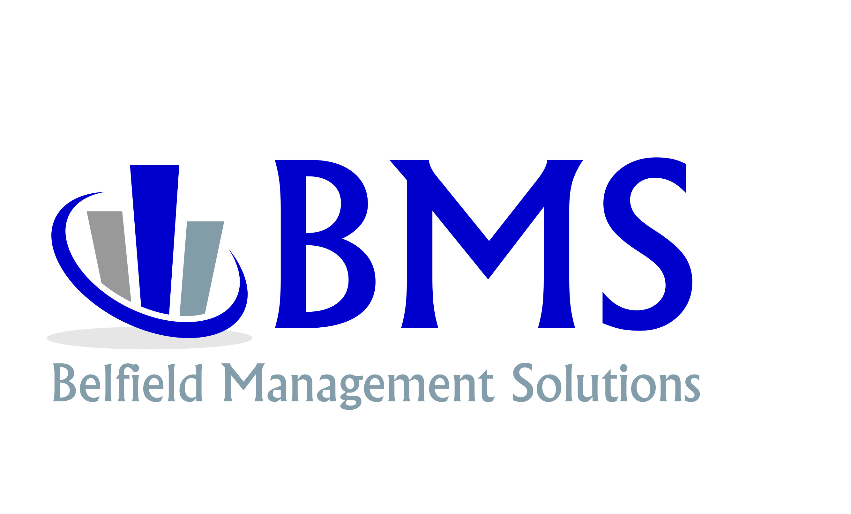

BUSINESS ANALYSIS

CONFIDENTIAL

About the Process

Belfield Management Solutions Inc. is a full-service management consulting firm. We practice pure, value-based business management consulting. Our consultants have experience with some of the largest names in the industry. Our corporate experience includes Deloitte & Touche. GE Financial Assurance, IBM Computer, University of Ohio, and Digital Equipment Company to name a few. Although our consultants have worked with many larger firms, our emphasis now is solely on small to medium-sized businesses, such as yours. We have been in all types of businesses from contractors of various trades, and building supply houses, to transportation logistics and the building of automobiles. Many companies continue to recall us for additional work as they experience growth from the work we did for them.

BMS Inc.is headquartered in Nashville, Tennessee, however we engage in projects nationwide. Although McDonald’s is the largest hamburger chain in the world, no one I know would choose McDonald’s as the absolute best hamburger. Similarly, though not the largest consulting firm in the world, BMS Inc. was formed by members of the top consulting firms in the world. Our methodology is to provide the “Best in Class” which is the most practical results-oriented approach of the Best in Class.

We have two operating departments. First are consultants who work through a licensing agreement with BMS Inc., of which I am a member. We serve as diagnosticians. We identify problems, problem costs, the potential of the business, the recommendations to correct the deficiencies, the benefits of correcting the deficiencies and an estimate of what will be required to correct any problem. Second is BMS INC. Management Consulting, they work with me. They serve as oversight and experience. I may not have 20-years of experience as a consultant; I work with a team that has implemented 1000’s of consulting projects successfully. If I don’t have the answer, I have a team of extremely experienced consultants and analysts that do. We work on all our projects as a collective. This collective experience would cost your company hundreds of thousands of dollars to hire this experience directly.

However, we differ from other consulting companies in that not only do we conduct an intensive business analysis, but our staff develops, designs, manualizes for future reference, and implements the corrective measures; teaching and training all concerned in their proper usage. But most importantly, we put the project in motion, all within the agreed upon time. Other companies conduct a survey, charge a per man hour rate from $395-$595 per hour. If they have a consultant and project manager on site, they are invoicing you $30,000 plus per week. Your small business cannot afford these expenses. This is the reason we work at a fixed monthly rate. It’s not about the amount invoiced weekly with us; it’s about making sure the project is implemented correctly at a rate that is affordable to you and your company. However, because of the concentration, time and experience required, small to medium sized businesses simply cannot make these corrections effectively by themselves. We might be professionally compared to a doctor in that we diagnose, prescribe, and effect a cure. It’s impossible for a business owner to work in your company and on your company at the same time.

Our findings are strictly and positively factually based on your operations. We must present exact evidence of problem areas in your business and a proposal of what we can do to help. Our report to you will be written utilizing factual charts and graphs in such a way that you will thoroughly understand our findings.

We charge a fee of $1,200.00 for a Business Analysis. If the company revenue is over $5 million in revenue, we charge $2,600 for the business analysis. We do not actually make any money on the business analysis fee, but this is our stock in trade - it is how we introduce clients to our service and demonstrate the value we can bring to the table. But we are confident that if you did not feel that you had some trouble or problem in your business you would not have called us in just to waste your time and ours.

We do not concern ourselves with management fads. We offer practical client tested management consulting “know how” gathered from our own extensive research and our constant touch with the nation’s businesses. Every recommendation we make has been battled-tested in real world situations like yours. However, we have no pre-set plans, no packaged products, no patent remedies. We recognize that each business has its own unique characteristics, and our individually tailored plans are based on scientific study and individual conditions. The result is that any work we do must be positive and permanent.

Our Management Consulting organizational fee is based on a fixed rate per month basis for an on-site consulting project. The consultant will be on site 2-3 days per month Unlike other companies that insist on irrevocable fees, we offer our service based on no contract whatsoever. We go to work for you monthly and must produce results each day we are on site in your company. The only factor which governs the length of our service is your own judgment of the results that you are receiving, and the value that you yourself place on those results. If you do not like the way Management Services is progressing, you are free to send them home. We prove to you on a daily and a monthly basis that you are receiving a substantial return on your investment.

The purpose of this Preliminary Business Analysis is to identify areas of weakness and strength, improvements that are possible, the net benefits to you not only in ease of operation, but also in additional dollar profits, and the number of hours it would take management services to correct any problems. In other words, to determine whether we can be of any help in reducing your costs, improving your operation, increasing your sales, or increasing your profits.

We may find problems which you are already aware of, and we will confirm them to you so you can take immediate, corrective action. We may find problems you are not aware of, and we will discuss these with you. We may find problems that are just too small to warrant outside management service. If our professional experience shows us that a two-to-one minimum return on investment is unlikely to be achieved, then we will make no recommendation for our service.

However, when we are finished with the survey and you concur with our findings, we do require a “Yes” or “No” answer whether you want us to make the improvements in your business. The reason we ask for a decision at the conclusion of the survey is that we have to pre-schedule our projects and clients. The logistical management and control of our personnel is essential to ensure proper effectiveness and coordination between our project management/support personnel and our clients/projects.

When we first received your Authorization for a Preliminary Survey, we did not know then, nor do we know now, if we would be able to accept this assignment for Management Consulting. At any given moment we may have three (3) to five (5) Senior Project Managers zeroed in on your business. However, neither you nor we can afford that much talent in your size business at any one time.

I work with our Management in our corporate headquarters in Nashville, Tennessee and throughout the country. The results of this survey will not be mine alone, but of Belfield Management Solutions Inc. Senior Management and mine. The $1,200.00-$2,600.00 survey fee is an organizational fee, just as the flat monthly rate is an organizational fee.

Consequently, we are immediately prepared to accomplish what we say can and should be done for you in your business, and when you concur with our findings and we have qualified you as a client, we expect the courtesy of an intelligent decision, Yes or No as to whether or not you want us to help you with the changes in your business. If it is not right, it must be wrong. I am sure you agree.

The length of the survey can be from less than a day to several days, depending on the problems we uncover. We will take only as much time as is necessary.

__________________________________________ I understand how the business analysis is performed.
Client Name

_______________________________________________________________ __________________________________
Client Signature Date

